

Project Report On
Arts(Online Shopping Cart)
Table Of Contents
- Acknowledgments
- Information About Developers
- Introduction About Project
- Analysis
- Screen Shots
- Final Statement

Acknowledgments

The combine Study on this project is an honor for our group members.
We were eager to make such a dynamic and interesting project, which may provide us with a huge amount of practical knowledge and will help us use our skills efficiently.
Our heartiest appreciation and gratitude towards our teachers, whose help, dedication and encouragement has helped our team members to successfully, achieve our goals.
We are grateful to Aptech for providing us necessary facilities and the support which we needed and also for providing us the opportunity to practically implement what we have learned, which will help, help us in future.

Information About Developers
Student1424565 | Mirsub khan
Student1425773 | Hassan ali
Student1426447 | Shayan shokat

Introduction About Project
The Arts(Online Shopping Cart ) website is a captivating online platform developed to showcase the exquisite varierty of products such as Stationary, Gifts, Toys etc.
This project seamlessly combines HTML, CSS, JavaScript, Php, MySql and Bootstrap to create an immersive and user-friendly website that caters to both aesthetic appeal and functionality With complete backend technologies.
By leveraging modern web technologies, the website provides a visually stunning experience while ensuring seamless navigation and easy access to information & shop according to their needs.
Whether it's exploring the extensive product catalog, requesting a quote, shop a products or contacting the company, the Arts(Online Shopping Cart ) website offers a delightful Shopping experience.
Analysis
Purpose
The purpose of the Arts(Online Shopping Cart ) website is to create an immersive online platform that showcases the diverse range of products and services offered by the company.
This project aims to provide a visually appealing and user-friendly & excellent UX website that effectively communicates the company's brand identity and values to potential customers.
By offering a seamless browsing experience, detailed product information, and convenient contact options, the website's purpose is to attract and engage users, for selling our products.
Working
Users can browse through the website's product catalog and discover a wide range of products offerings. They can buy & view product details, such as descriptions, prices, dimensions, and images, to gain a better understanding of the available options.
Snapshots
Home page
This is the home page of website
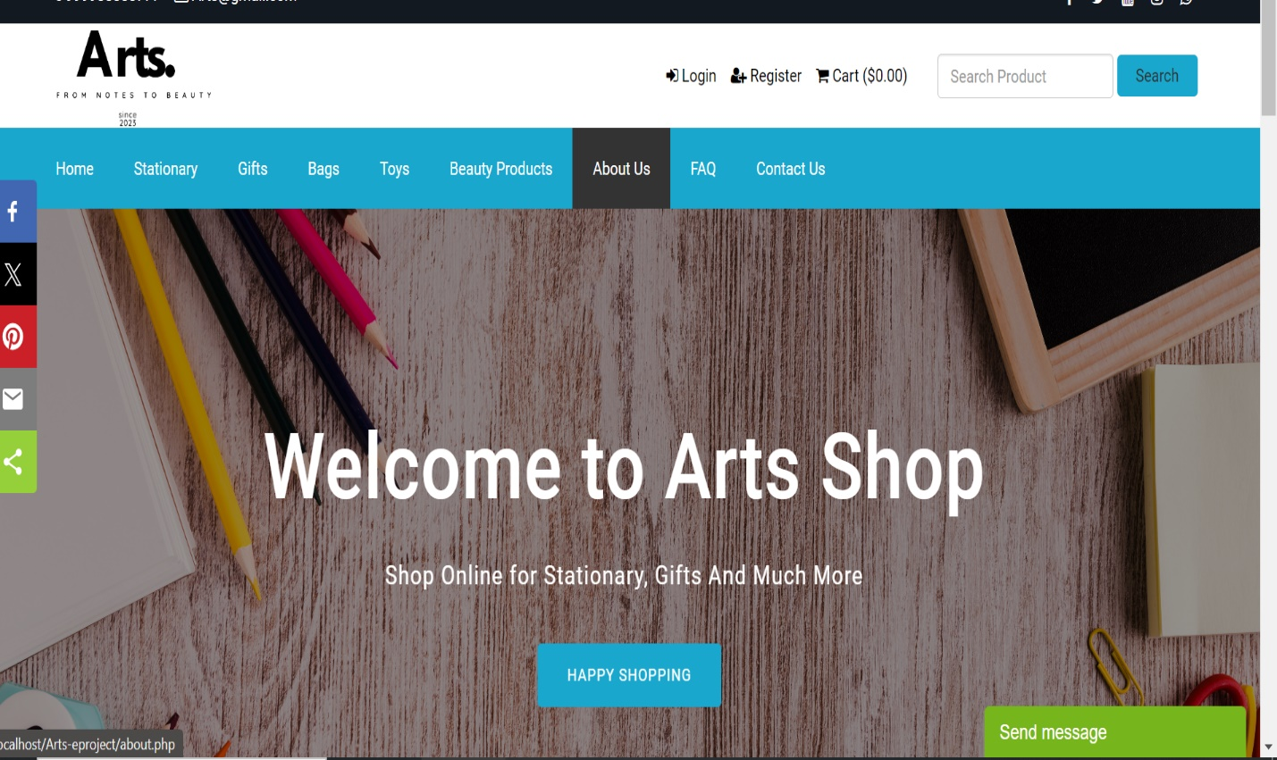
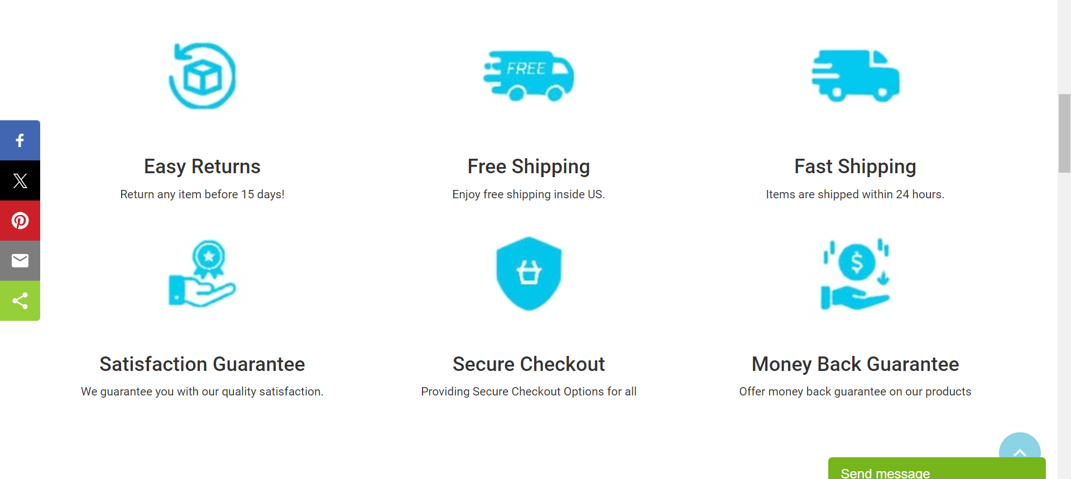
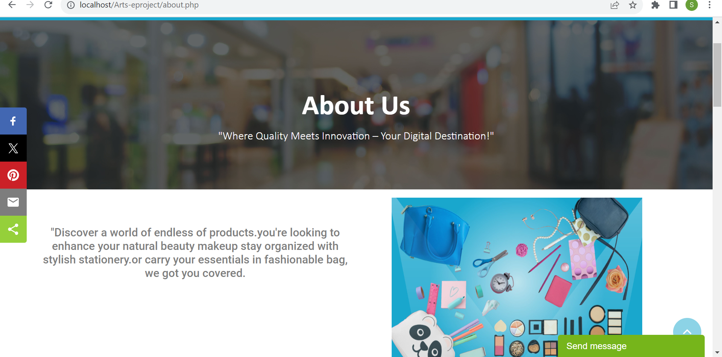

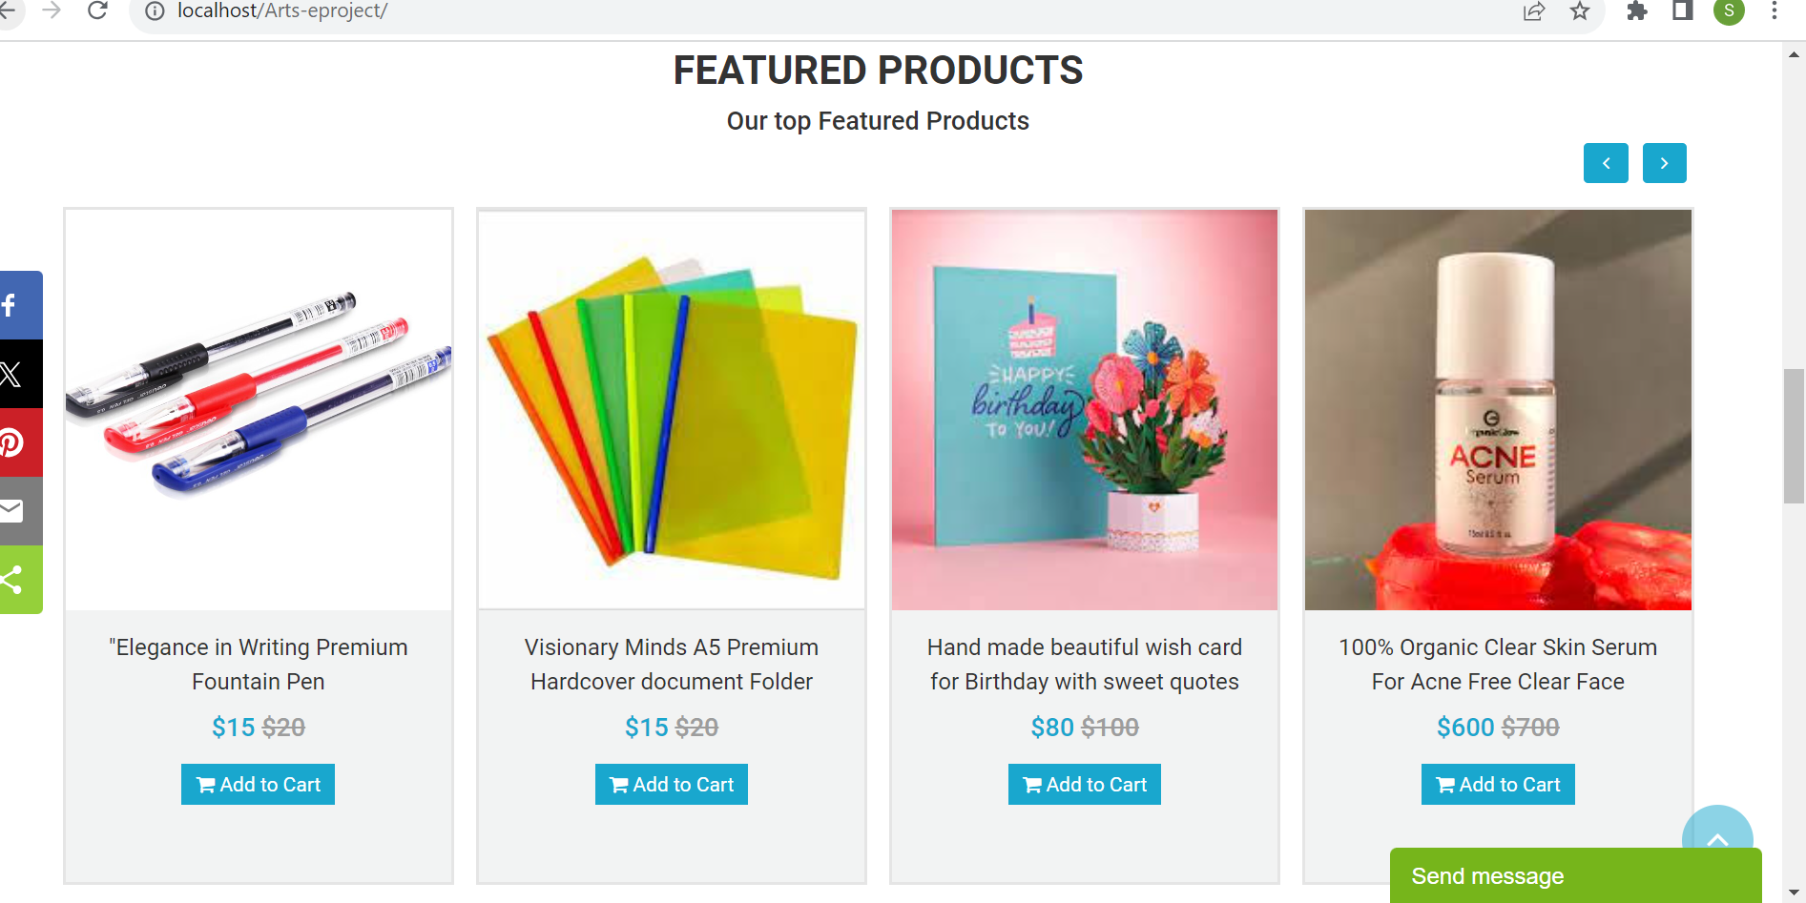
Product page
From this page customer ca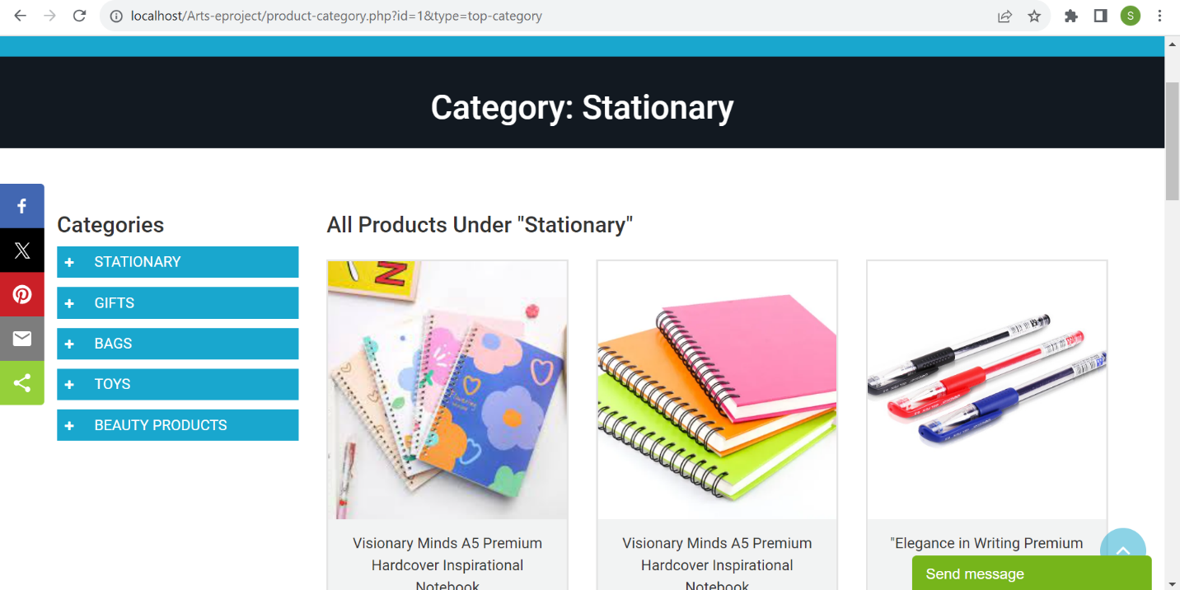n shop and explore furniture
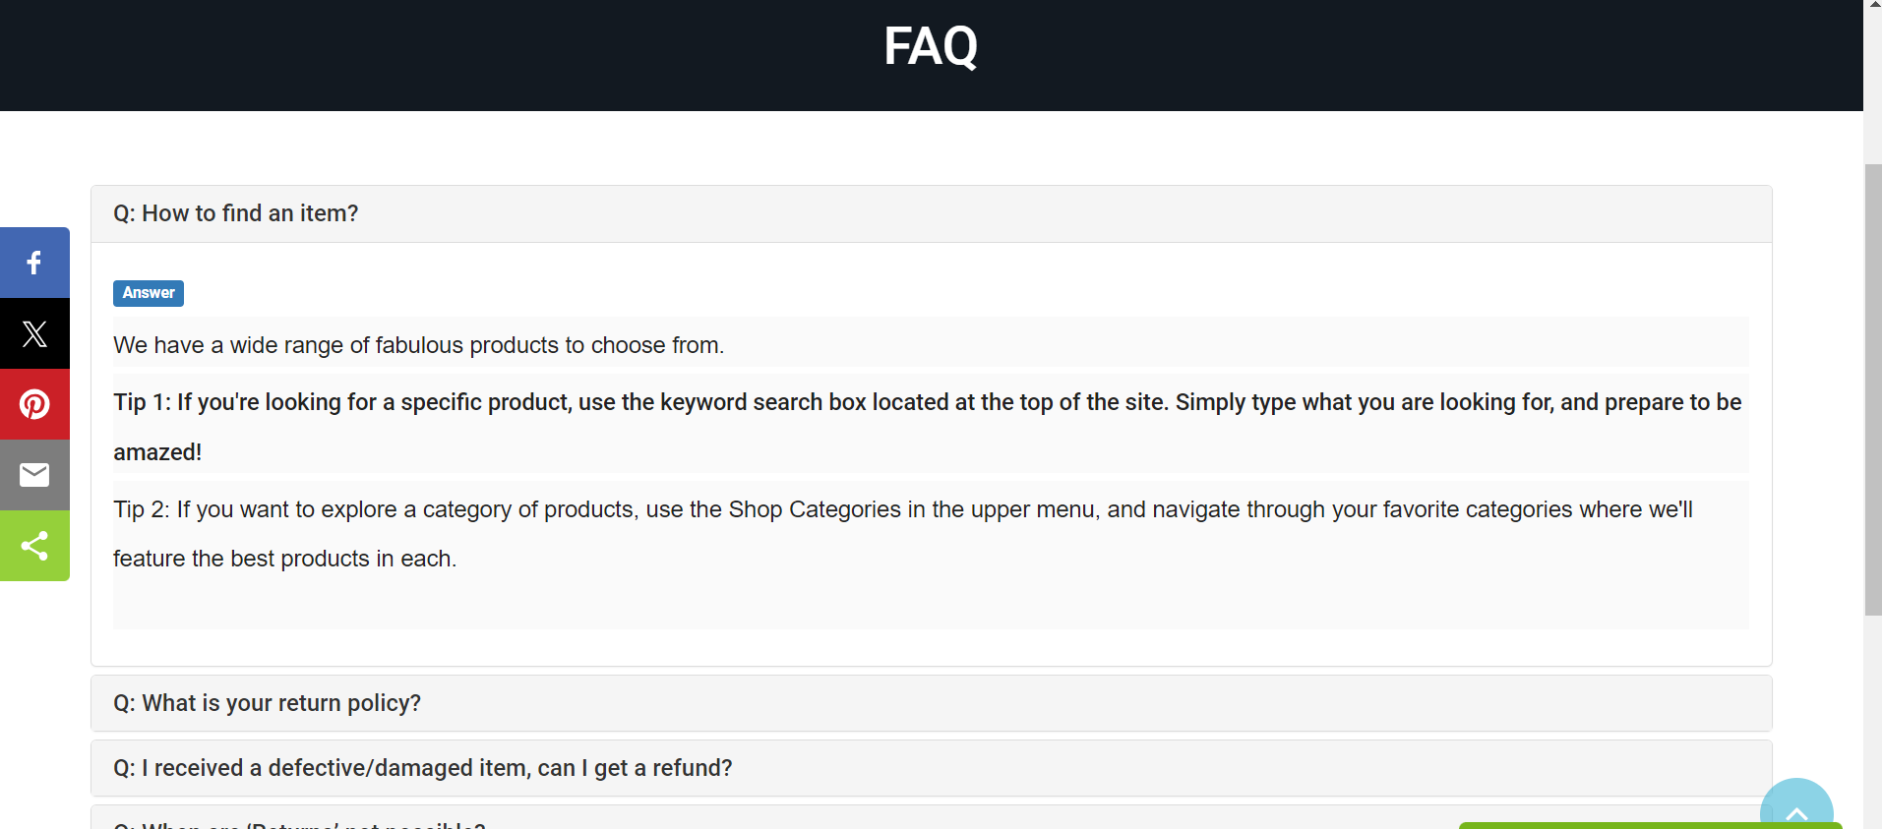

Contact us page
Customers can contact us through this page

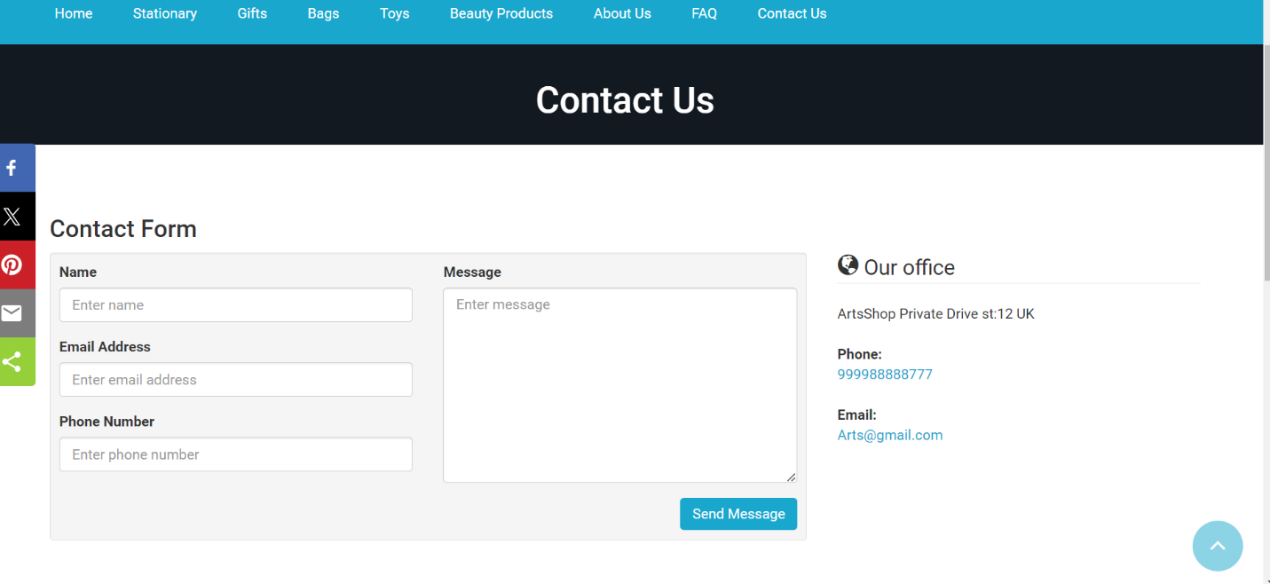
Through this map customers can visit our store
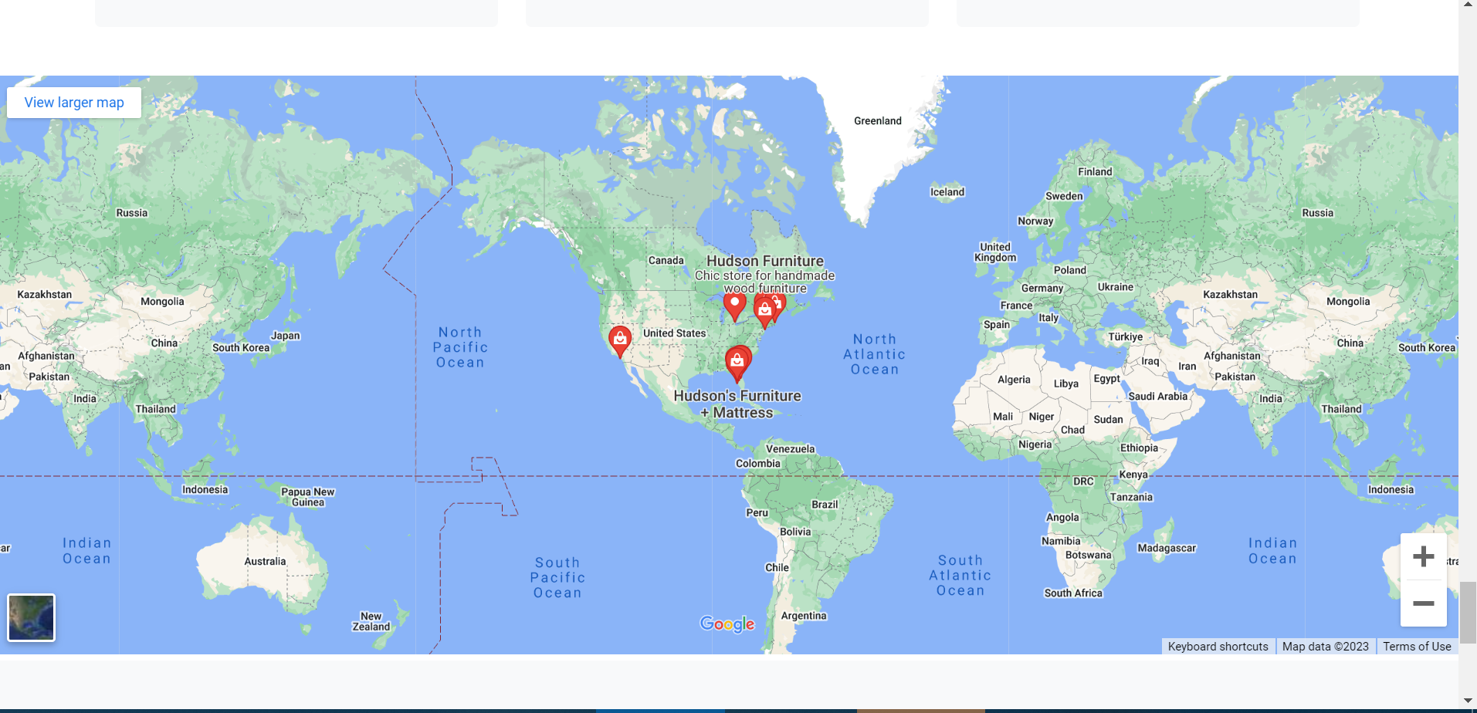
About us page
From this page customer can know our goals and history and team

Final Statement
This E Project was created with Firm Determination. We students did lot of hard work to complete this project on time.
We did our best to made this project perfect, work full, help full, easy to use and Qualified as much as possible.
We Kept the future technologies and usage in our mind while making this project.
We hope That APTECH will like our project and will appreciate our hard work and Firm Determination.
THANK YOU!
Documentation Created By
Hassan ali
Mirsub khan
Shayan shoukat

